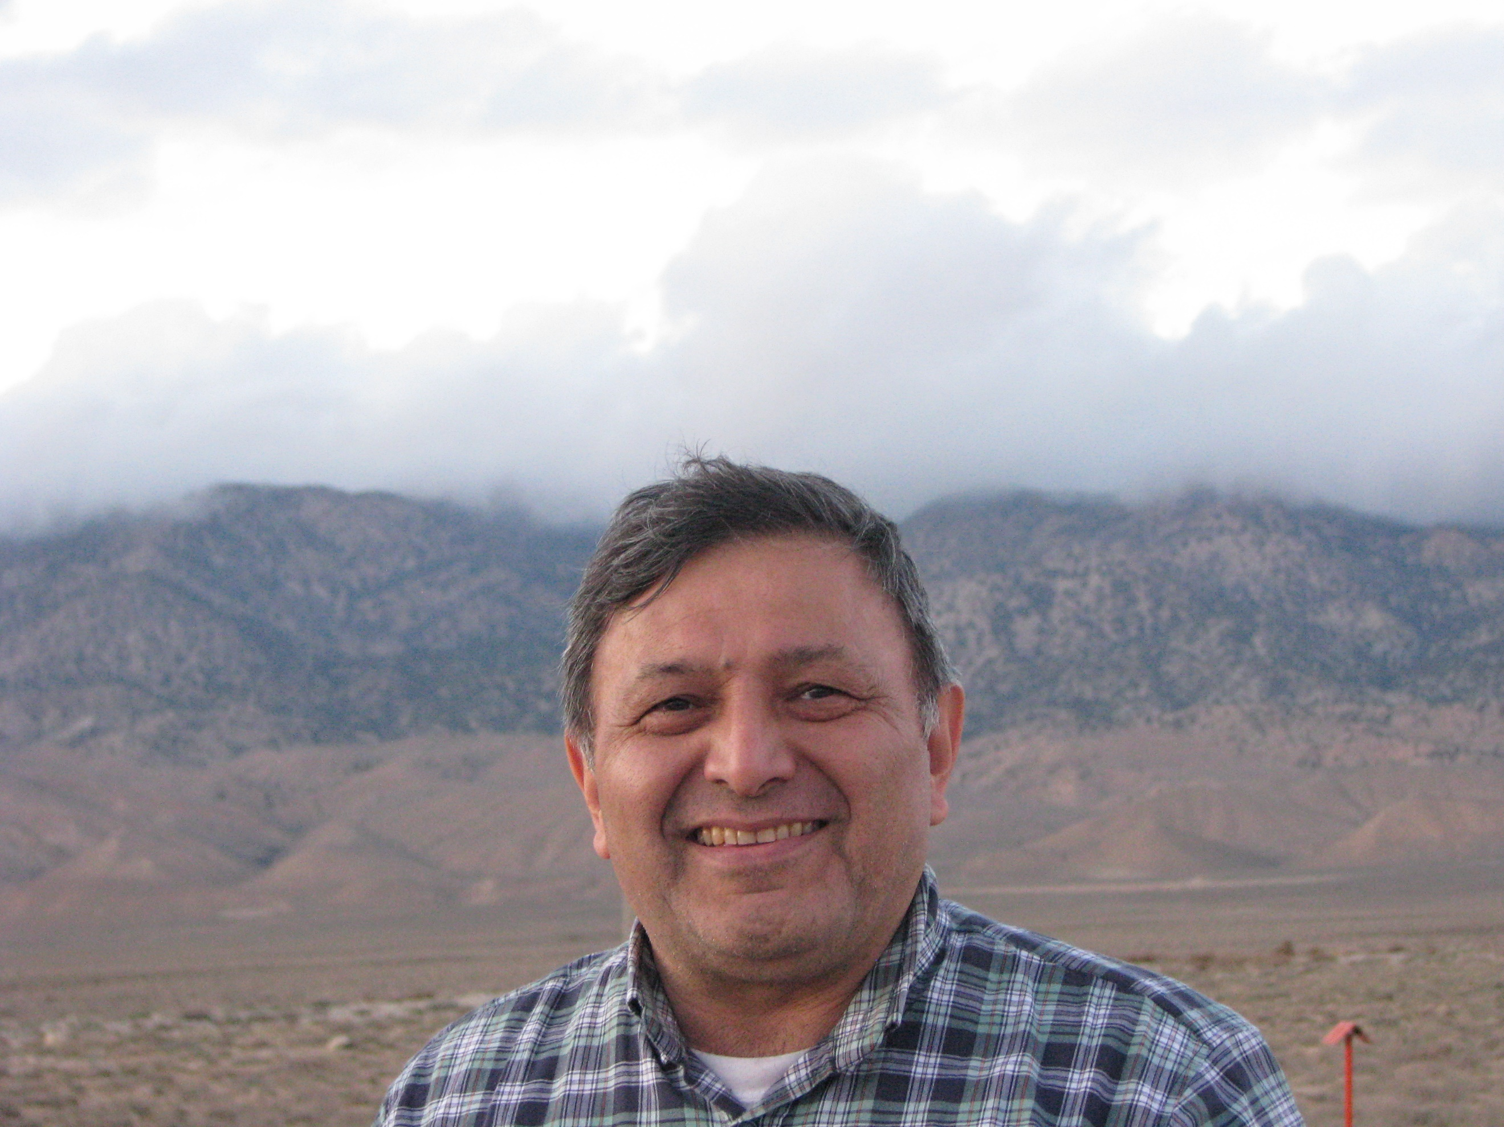 |  | Yasha Makhdoumi  Radiation Oncologist
Profile  Born :1965 Tehran, Iran  Turkmen ethnic  Iran citizenship  Father name: Eraz Makhdoumi 1933-2005 Turkmen ethnic  Mother name: Ayesheh Makhdoumi born 1941 Turkmen ethnic  Contact  PHONE:  00989121388109  00989153253980  Address:  Apartment no 4, block 9  Khayyam complex, Ferdowsi 2 street  Mashhad, Iran  Post code 9185973615  EMAIL:  makhdoumi@gmail.com  makhdoumi@isco.ir  makhdoumiy1@mums.ac.ir  Hobbies  Chess  Table tennis  Music  Travel  See movies  Reading books |  | EDUCATION  1979 to 1983  Gonbad kavous Magtymguly high school  For getting science diploma  1983 to 1990  Mashhad Medical Science University  To be a Medical Doctor and General practitioner with good degree to go to residency course directly  1990 to 1994  Mashhad Medical Science University  Residency of radiotherapy oncology to be Radiation Oncologist  WORK EXPERIENCE  1994 to 1999  Tabriz Medical Science University  Radiation Oncologist  Scientific member of Radiology Radiotherapy and nuclear medicine department  Treating cancer patients with radiotherapy and chemotherapy and research and guide of thesis of medical science students and nurses and medical physic students  Director of radiotherapy Department  1999 to 2001  Urmia Medical Science University  Radiation Oncology  Treating cancer patients with radiotherapy and chemotherapy  Director of radiotherapy and oncology department of Omid oncology center in Urmia  2001 till now  Mashhad medical Science University  Radiation oncologist  Director of cobalt radiotherapy from 2001 to 2006  Treating cancer patients with radiotherapy and chemotherapy  Executive member of cancer research center of Mashhad medical science university  2004 to 2021  Director of Khorasan branch of Iranian Association of Radio oncology  2006 till now  Technical manager and director of radiotherapy department of Reza oncology center of Mashhad  Consultant of CEO of Reza Charity center for supporting cancer patients  2017 to 2021  Member of directors and treasurer at Iranian Association of Radio oncology  2021 till now  Director of Iranian Association of Radio oncology 2021 till now  Skills  Radiotherapy with linear accelerator  Brachytherapy (gynecological and esophagus and rectum and nasopharynx)  Chemotherapy  Immunotherapy  Electro chemo poration  languages  Turkmen native  Persian native  Azari native  Turkish fluent  English fluent

